Researcher Biography
Name: Joanne Bolton
Role: Interprofessional Education and Practice Development Fellow
Institutional affiliation: University of Melbourne
I would like to acknowledge the Wurundjeri people as the traditional custodians of the lands on which I live, work, study and learn, and I pay my respects to all Elders past, present and emerging. I am motivated by a vision of both national and global health equity and moved into health professions education from a clinical background in physiotherapy 7 years ago. I see education as an upstream way of being involved with the training of the future healthcare workforce and I would like to contribute to facilitating changes in the way in which healthcare is positioned, prioritised and practiced. I am interested in exploring curriculum design that actively seeks to prioritise the essential humanistic domains of culturally safe and collaborative person-centred healthcare delivery.
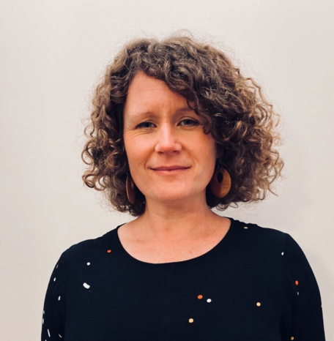

Project Summary
Title; Ways of Knowing in healthcare- an interprofessional immersive approach
Names of the research team: Ms Joanne Bolton, Dr Sarah Meiklejohn, Dr Ngaree Blow, Dr Karen Donald, Professor Elizabeth Molloy, Dr Kate Reid
Curriculum Planning Team: Associate Professor Louisa Remedios, Associate Professor Anthea Cochrance, Dr Zerina Tomkins, Mr Josh Cubillo, Dr Cindy Ahern, Ms Tamara Clements
Institutional affiliations: University of Melbourne
Contact details of the corresponding author: joanne.bolton@unimelb.edu.au
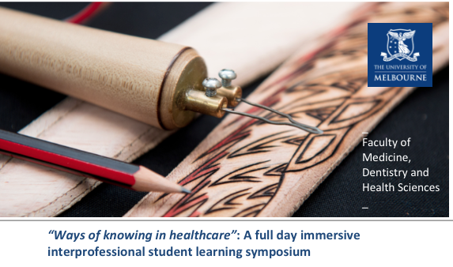
Take home messages:
- Interprofessional curricula that explores First Nations health and collaborative practice provides a platform to explore the authentic development of cultural safety and interprofessional education competencies
- The interprofessional tutorials with interactive case studies and interprofessional panel session were viewed by students and educators as key to the success of the ‘ways of knowing in health care’ curriculum
- The co-facilitation by both a First Nations health tutor as well as a non-Indigenous Faculty staff member was highlighted as valuable learning experiences by both educators and students
- Further exploration of both educator and students shifts in ‘ways of knowing’, resistance to engagement and evidence of behaviour change is required, as well as ongoing design of pedagogy (nested tasks) across the length of programs to build on these capabilities

Background:
Entry-to-practice health professional programs are increasingly required by accreditation standards to demonstrate that their curriculum explicitly includes First Nations health and wellness as well as interprofessional education. Educators in the Faculty of Medicine, Dentistry and Health Sciences at the University of Melbourne recognised the significant potential for First Nations health teaching to authentically build skills in critical reflective practice, holistic care, person-centered care, effective communication and teamwork in an interprofessional context. In 2020, a new ‘Ways of knowing in healthcare’ interprofessional symposium was developed and implemented as a pilot core curriculum activity. The aim was to develop a heightened understanding of ontology, epistemology, cultural safety, First Nations health and collaborative practice. (112 words)
Aim:
The research questions were:

- What are students’ perceptions on the extent to which the ‘Ways of knowing in healthcare’ symposium achieved the intended learning outcomes?
- What changes did students experience in their understanding of ontology, epistemology, cultural safety, First Nations health and interprofessional practice?
- What core competencies of interprofessional collaboration were built by health professional students?
(59 words)

Study Design and preliminary results
Ways of Knowing was delivered in February 2020 to 680 students across four disciplines: medicine, physiotherapy, nursing and optometry. Five phases were proposed to explore the research questions.
Phase 1: On-the-day paper-based student feedback to explore immediate student perceptions
Phase 2: An online tutor survey delivered two-weeks after the symposium. Phase 1 and 2 were undertaken as part of an evaluation designed to inform improvements to the symposium and did not require ethics approval. Phase 3: Anonymous and non-compulsory online survey within three months of the symposium that explored student’s reflections of learning over time and applied learnings since the symposium, ethics approval HRE 2056211.2

The response rates for Phases 1, 2 and 3 were 327 respondents (47%), 14 respondents (45%) and 47 student respondents (13%) respectively. The lower than anticipated response rate for Phase 3 was likely due to the concurrent timing with the COVID-19 pandemic.
Phase 4: Analysis of student written reflective assignments within six months of the symposium, ethics approval HRE 2056211.2 Phase 5: Systematic literature review to explore the use of curriculum-based interventions aimed at developing cultural safety and interprofessional education
Phases 4 and 5 were not able to be completed due to the COVID-19 pandemic.

Subsequent progress:
The Planning Team for 2021 have used results from Phases 1–3 of the evaluation to inform the curriculum design for the expanded ‘Ways of knowing in healthcare’ extending to 1200+ students across eight disciplines (medicine, physiotherapy, nursing, optometry, audiology, dentistry, speech pathology and social work).
Joanne Bolton, Shawana Andrews, Dr Ngaree Blow & Assoc Prof Louisa Remedios successfully secured a $24,000 University Learning and Teaching Grant to create two new online interprofessional learning modules, one for staff and one for students on ‘Teaching and Learning Together: Cultural Safety Essentials’ which will form part of the ‘Ways of knowing in healthcare’ curriculum for 2021.
We aim to further explore our research questions in 2021 with the refined curriculum and look forward to sharing our results with the ANZAHPE community.

